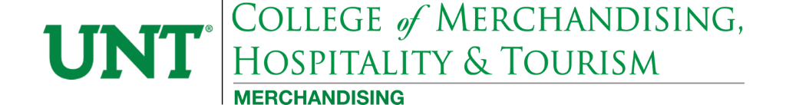

**DRTL 4000.003 Digital Study Tour**

**Summer 2025 Student Application**

|  |  |  |  |
| --- | --- | --- | --- |
| **Name** |  |  |  |
| **EUID** |  |  |  |
| **Phone** |  |  |  |
| **E-Mail Address** |  |  |  |
| **Major(s) & Minor** |  |  |  |
| **Classification as of Jan. 2024** |  | | |
| **List class you have earned a C or better in – DRTL 2090** |  | **Expected Graduation Date (Semester & Year)** |  |

**How to Apply:**

1. Submit your completed application with unofficial transcripts from **Feb1-March 15 (all classifications).** Applications will only be accepted via email.Send your application to Ms. Ratnam at Malini.Ratnam@unt.edu.
2. The class is capped at 14 students. First come, first serve as space is available. Preference is given to Merchandising and Digital Retailing department majors.
3. Juniors and seniors can apply during the first application period since they are closer to graduation. Freshmen and sophomore applications are considered during the second application period.

**Once Application is Approved:**

1. You will receive an email stating confirmation of application approval.
2. After receiving application approval, you should secure airfare to and from San Francisco. When booking your flight, you need to keep start and end of the study tour in mind. Students need to attend a required meeting at the hotel in NYC at 6:00 pm on Sun May 11. The tour officially ends Fri May 17 . It is recommended that you fly in and out of New York (LGA or JFK) but you can book your airfare as you’d like.
3. Submit proof of airfare to Ms. Ratnam by March 31, 2025 by 11.59pm, or you will lose your spot for the tour.

**Note that an approved application does not secure your spot.   
Approval and proof of airfare guarantees your spot.   
Purchase your airfare by March 31 to secure your participation in the Digital Study Tour.**

**DRTL 4000.002 New York Digital Study Tour Information**

This course is designed to engage students in an intense study of an area pertinent to the field of digital retailing. New York City or the Big Apple serves as a prime venue for those pursuing a career in digital retailing. Students will experience the ecommerce and digital industry through visits to retail corporate offices, digital and tech companies and more.

There will be pre-trip and post-trip class meeting times that are required during the 5-week summer session. Students MUST be available for these meetings and will be expected to give reports, engage in discussions, and learn about policies and guidelines for the trip. While in New York, you are expected to attend all scheduled events in a professional manner (i.e. well groomed, on time, and alert).

**What is provided in the study tour?**

* Accommodations at a mid-town hotel for 5 nights with 3-4 people per room
* All transportation to and from professional appointments and sponsored activities in NYC via the public transit system (exclusive of free time)
* All professional appointments
* All admission costs indicated on itinerary (e.g., MMA, Broadway show)
* All taxes, gratuities and service charges related to the above

**What are the costs associated with the study tour?**

* ***UNT Tuition & Fees*** - The course runs during 5-week summer session in June/July.
* Round trip transportation between New York and Dallas/Fort Worth and transfers between hotel and airport on arrival and departure
* Airline baggage and handling fees
* Free time events including personal transportation (taxi, Uber, etc.), food, shopping, and tipping
* Travel from home to DFW Airport for both arrival and departure

**What pre-requisites must be met in order to take part in the tour?**

* Completion of DRTL 2090 with a C or better
* Good academic standing meeting DR minimum catalog requirements for UNT GPA, and consent of DR Instructor
* Declared Digital Retailing, Merchandising majors will receive first preference

**MARK THESE IMPORTANT DATES!**

**Feb 1 – March 1: Begin accepting applications and transcripts from juniors and seniors via email**

**Students of all classifications can apply**

**After application approval, purchase and submit proof of airfare by this date to secure your spot**

**March 31, 2025: Registration codes will be emailed to students who have secured a spot in the study tour**

**May 19- May 22 2025: Post-trip meetings from (required)**

**May 11-17: New York travel dates (required)**