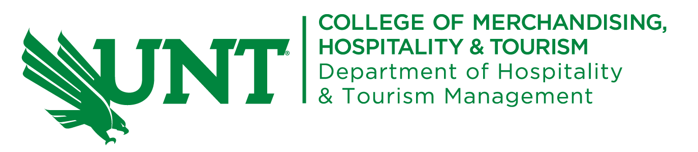
Hourly Student Employment Request for New Hospitality Management and International Sustainable Tourism MS Students.
Overview:
The Hospitality and Tourism Management department employs a limited number of graduate students in hourly paid positions to assist HTM faculty in their course preparation, management and grading.
As a new incoming graduate student, you may choose to submit this request to be considered for an hourly position in the HTM department. Hours assigned may range up to 20 hours per week as determined by the department chair.
There is not a deadline for this request and positions are filled as needed until the beginning of each semester.

_____ I would like to be considered for an hourly student assistant position:

PERSONAL INFORMATION:
Name: ____________________________________________
Student ID#: __________________ EUID#: _______________
Phone Number: _____________________________________
E-mail: _____________________________________________

My MS degree program is:
___ MS Hospitality Management
___ MS International Sustainable Tourism

Admission Status:
____ I have been accepted into my MS program.
____ I have applied and my application is in the review process.
New MS Students:
Semester you will start MS program: _______________________
Tuition residency status without waiver:
_____ Resident tuition (instate) or
_____ Non-resident tuition (out-of-state)

Were you required to submit proof of English Proficiency when applying to UNT? ____ Yes ___ No
If yes, what exam and score ______________________ or IELI completion date ________________

REQUIRED SUPPORTING DOCUMENTS:
- Transcripts will be provided by the Graduate Coordinator.
- For currently enrolled students: A copy of filed degree plan or updated degree plan.
- A copy of the official admission letter with any conditions listed.
- A statement on your desire to be a student assistant along with any prior experience related to teaching or course management.
- A current resume.

Submit Request and Documents to:
Ken Marie Richards, Assistant to the HTM Chair
E-mail: Ken.Richards@unt.edu
Phone: 940-565-3370

